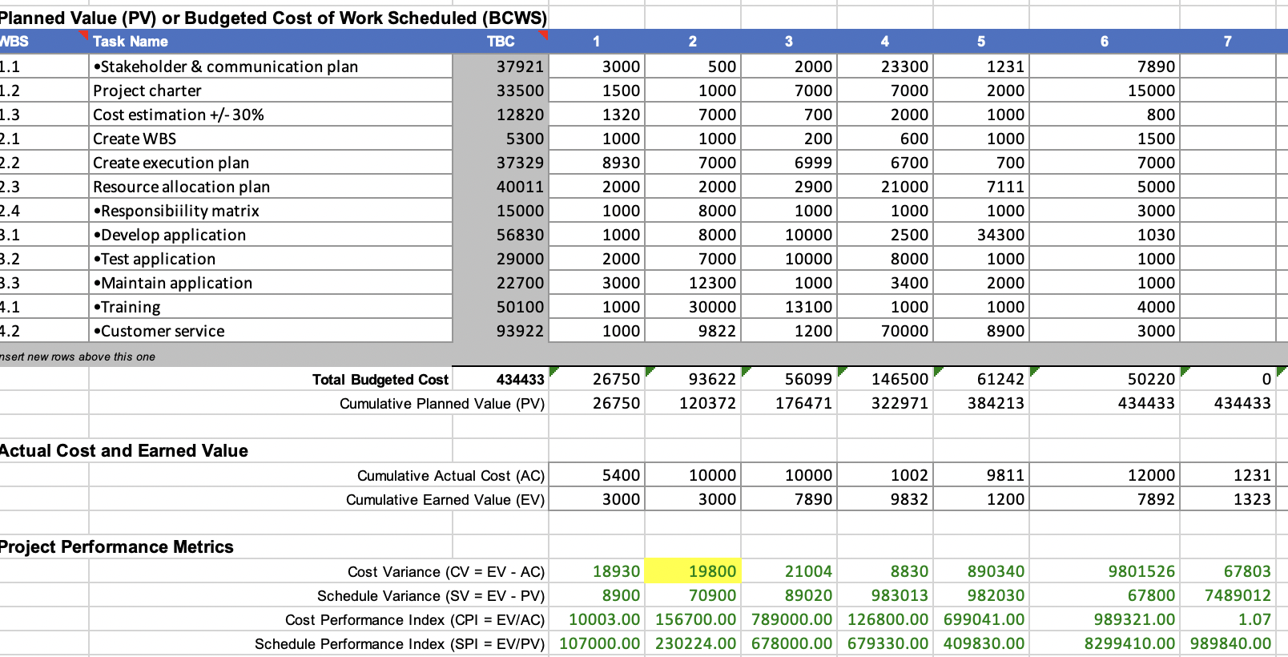

CV = EV - AC

* ETC = (total budget - EV) / CPI.
* EAC = AC + ETC.
* SV = EV - PV
* CV = EV- AC
* PV = scheduled progress \* budget.
* SPI = EV/PV